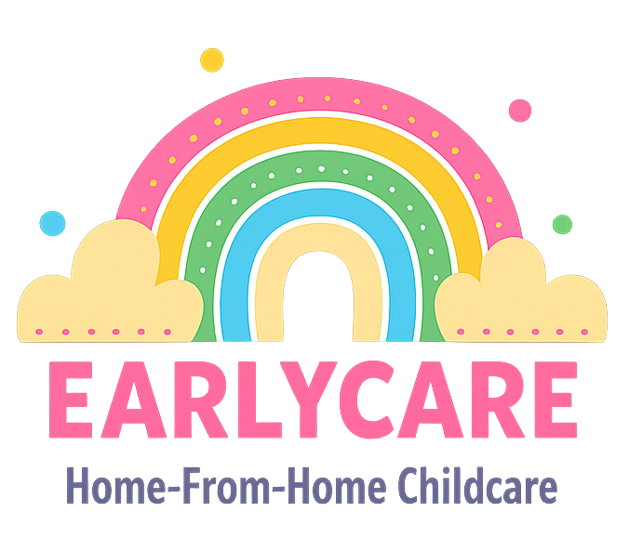

Earlycare

COMPLAINTS POLICY

Approval and Review

Manager | Mrs Hannah Bull
Signature | H.BULL
Policy Review Period | 12 months
Date of Policy Review | July 2026

Version Control

Version | Date Approved | Changes | Reason for Alterations
Initial | Jan 2024 | New policy
 | Jan 2025 | None
 | July 2025 | None

As a registered setting, we aim to work in close partnership with all parents to meet the needs of their children. However, if there is any aspect of our service that does not meet your expectations, we are happy to discuss this with you. If you feel comfortable communicating this verbally, we can hopefully resolve the issue right away. If you would prefer to make a complaint in writing, you can send this to my email address (earlycarechildminding@yahoo.co.uk) or by post.
It is a condition of our registration to investigate all written complaints relating to the safeguarding and welfare requirements of the EYFS. We will notify the complainant of the outcome within 28 days of receipt of the complaint. It is a requirement by Ofsted that all complaints are logged, along with the outcome and any action taken.
We will record the following information:
- the name of the person making the complaint
- the EYFS requirement to which the complaint relates
- the nature of the complaint
- the date/time of the complaint
- any action taken in response to the complaint
- the outcome of the complaint investigation
- details of the information and findings that were given to the person making the complaint, including any action taken
If we cannot resolve an issue between ourselves and you wish to make a formal complaint then you can contact the Ofsted Complaints and Investigation Unit on 03001231231 or you can write to them at Applications, Regulatory and Contact Team, Ofsted, Piccadilly Gate, Store Street, Manchester, M1 2WD.
We will keep a written record of complaints and their outcomes for at least three years.

