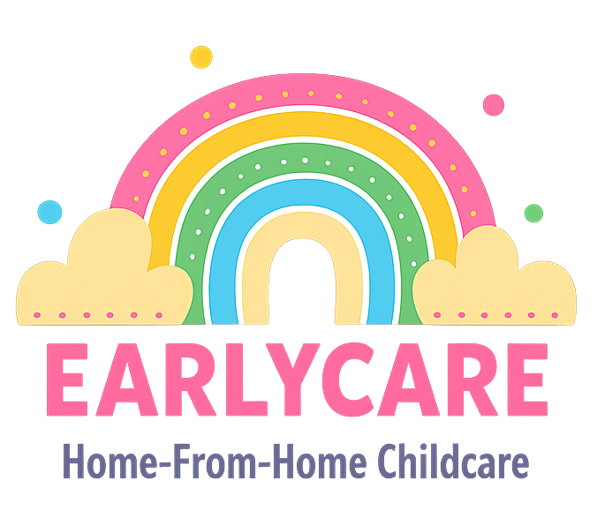

Earlycare

HEALTHLY EACTING AND FOOD HYGIENE POLICY

Approval and Review

Manager | Mrs Hannah Bull
Signature | H.BULL
Policy Review Period | 12 months
Date of Policy Review | July 2026

Version Control

Version | Date Approved | Changes | Reason for Alterations
Initial | Jan 2024 | New policy
 | Jan 2025 | None
 | July 2025 | None

Any meals, snacks and drinks provided to children in the setting will be healthy, balanced and nutritious. Any person(s) preparing or handling food will be competent to do so and trained to an appropriate level in food hygiene practices.
We will obtain, record and act on information from parents about a child’s dietary requirements.
In the interest of safety and children's health, there are a few items that should not be included in lunch boxes:
- glass bottles and jars
- fizzy drinks and pre-mixed drinks high in sugar
- chocolate bars or sweets
If a child regularly brings meals from home that are far too high in fat/sugar/salt and do not have enough nutritional value, this will be discussed with parents. If they are struggling to provide a balanced diet due to selective eating for any reason, then we will recommend they access support via their health visitor or GP.
Where parents provide meals for their children to eat in the setting, we will provide chilled storage for packed lunches and appropriate storage areas for other foodstuffs.
We will also provide clean, age appropriate crockery and cutlery to enable the children to eat a packed lunch.
Children will be provided with healthy meals and other healthy snacks and drinks recommended by the Food Standards Agency literature. We will encourage children to try a bit of everything they have been given, even if they claim not to like it. We will give them lots of praise for tasting something new and will never pressure them if they say they don't want to eat something.
Fresh drinking water will be available at all times.
As a provider of meals and snacks, We are aware of our responsibilities under food hygiene legislation. This includes, if necessary, registration with the relevant Local Authority Environmental Health Department. If this is the case, we are happy to have my premises inspected by a food safety officer.
Potentially dangerous substances, such as bleach and laundry detergents, will not come into contact with food preparation areas.
If there is an outbreak of food poisoning affecting two or more children looked after on the premises, we will notify Ofsted as soon as possible, within 14 days of the incident, in order to comply with regulations.

