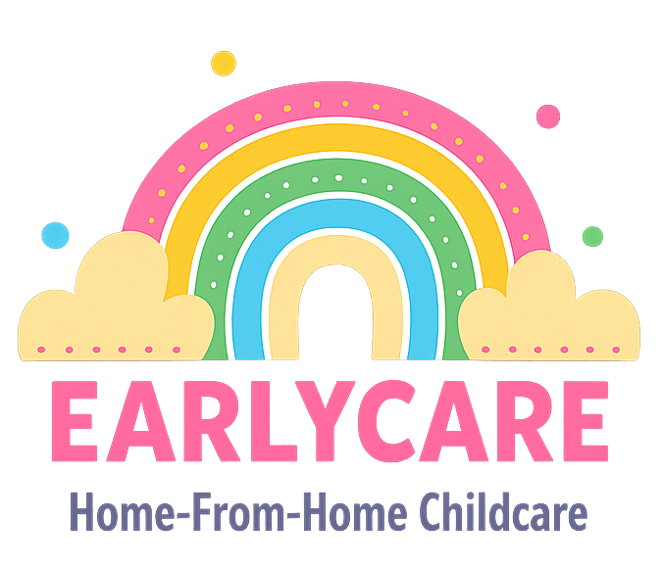

Earlycare

SICKNESS, ILLNESS AND INFECTIOUS DISEASES POLICY

Approval and Review

Manager | Mrs Hannah Bull
Signature | H.BULL
Policy Review Period | 12 months
Date of Policy Review | July 2026

Version Control

Version | Date Approved | Changes | Reason for Alterations
Initial | Jan 2024 | New policy
 | Jan 2025 | None
 | July 2025 | None

It is our policy to keep children safe when they are in our care, promote good health and take necessary steps to prevent the spread of infection within the childcare setting.
We are willing to care for children with minor coughs and colds but will not be able to care for children who are very unwell, infectious or running a high temperature, as we must consider the welfare of all other children in our care.
All children in the setting who are excluded due to having sickness and/or diarrhoea, will not be allowed to return until they have been free from symptoms for 48 hours. This is to minimise the risk of transmission of an infection to other children or staff members. You must tell us before arriving at EarlyCare if your child has been ill or taken any medication (including paracetamol) in any 48 hour period before we look after them, giving details of any medical advice received. This information must be shared with us, even if the child no longer shows any symptoms. Depending on the reason for taking this medicine, we may not be able to accept your child until they are well again. If your child has become ill with an infectious disease such as Hand, Foot and mouth, Slapped Cheek, Chicken Pox, impetigo or any other then we will follow the Public Health guidance, however with Hand, Foot and Mouth we have a five day exclusion due to how infectious and quickly it can spread.
If your child becomes ill whilst in our care, we will contact you to collect them as soon as you can and make them as comfortable as possible until you arrive. If you cannot collect your child within an hour, please make arrangements for them to be collected by another suitable adult, preferably somebody known to us or on your emergency contacts list.
Depending on the illness and its symptoms, we may not be able to provide childcare during/following a child's illness. We will, generally, use Health Protection Agency Guides to determine whether an illness warrants a child staying at home and for how long.
If your child is absent due to illness, full fees will still be expected, as we are still open for business.
If we believe a child in the setting is suffering from a notifiable disease identified in the Public Health (Infectious Diseases) Regulations 1988, we will act on advice given by the Health Protection Agency and inform Ofsted of any action taken. We will follow RIDDOR guidelines of reporting such instances.
If we are forced to close due to a public health notice (for example COVID-19), then we cannot legally enforce payment of fees for the service we cannot provide. However, in order to keep your child's place open, we request a voluntary contribution of £100 during the period of our closure.

