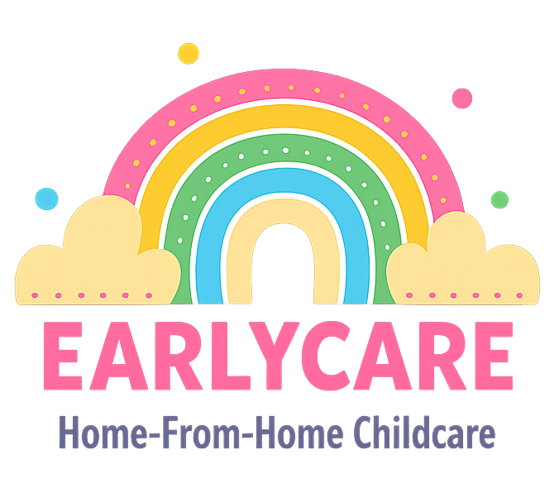

Earlycare

HEADLICE POLICY

Approval and Review

Manager | Mrs Hannah Bull
Signature | H.BULL
Policy Review Period | 12 months
Date of Policy Review | July 2026

Version Control

Version | Date Approved | Changes | Reason for Alterations
Initial | Jan 2024 | New policy
 | Jan 2025 | None
 | July 2025 | None

Children with head lice will not be excluded from our care, but we would ask that these recommendations are followed in order to try to prevent other children becoming infected:
- Parents inform us immediately if they have discovered that their child has head lice.
- Children should begin treatment before attending the setting if head lice are identified.
- Children with long hair wear their hair up to prevent the spread of infection.
- Parents check their children’s hair regularly with a special head lice comb.
We hope that the parents of children with head lice will work with us to treat and prevent the spread of the infection. We also ask that all children and parents are sensitive and understanding towards the subject of head lice, as it is not the fault of the child who is infected. It also does not imply a lack of hygiene or cleanliness.
More information about how to treat and prevent head lice can be found by visiting the NHS website. You should also be aware that to treat head lice effectively, you will need to repeat treatments at the intervals specified in the NHS guidance.
If we notice or are told that a child in our care has head lice, we will inform the parents of the other children in our care. We will not disclose which child it is who has the head lice, to keep the confidentiality of the other child and parents.
We will assist in the prevention of head lice by ensuring that children in the setting do not share things, such as role-play hairbrushes and combs, or dressing-up props such as hats and wigs, if a case has been reported in the setting.

