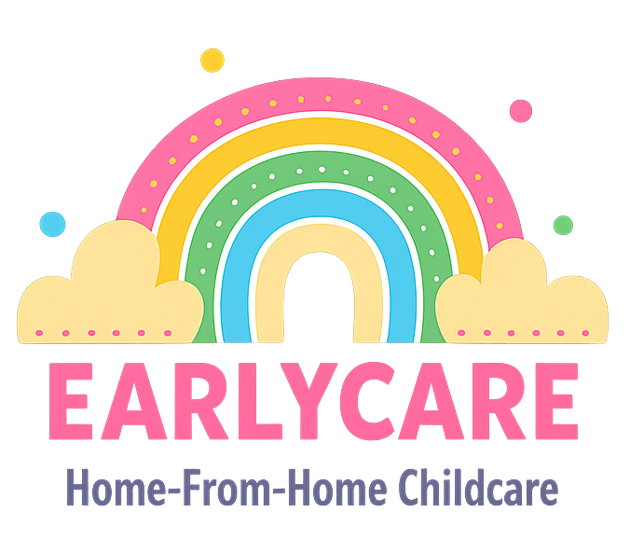

Earlycare

EQUAL OPPORTUNITIES POLICY

Approval and Review

Manager | Mrs Hannah Bull
Signature | H.BULL
Policy Review Period | 12 months
Date of Policy Review | July 2026

Version Control

Version | Date Approved | Changes | Reason for Alterations
Initial | Jan 2024 | New policy
 | Jan 2025 | None
 | July 2025 | None

We will make sure that we actively promote equality of opportunity and anti-discriminatory practices for all children and their families. We will make sure that we treat all children with equal concern and respect.
We recognise and welcome all legislation and existing codes of practice produced by appropriate commissions, for example the Equality and Human Rights Commission.
We value and respect the different racial origins, religions, cultures and languages in a multi-ethnic society. We oppose discrimination against any child, person or family on the grounds of race, ethnic origin, colour, cultural background, language, religious belief, nationality, gender, marital status, sexual orientation, disability, health status, social class or other such factors. We will challenge any remarks we feel are inappropriate.
We provide equal chances for each child to learn and develop to their full potential, taking into account each child’s age and stage of development, gender, ethnicity, home language and ability.
We provide and make sure that all the children have access to a range of books, puzzles and other toys which provide positive images and examples of the diversity of life in our society.
We challenge racist and discriminatory remarks, attitudes and behaviour from the children in our care and other adults.
In our setting, children will learn about how our differences should be celebrated. They will be encouraged to embrace their own unique qualities and develop a positive image of themselves, as well as their own family and community.

