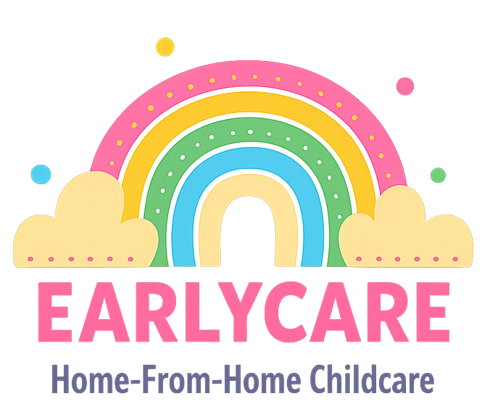

Earlycare

BEHAVIOUR POLICY

Approval and Review

Manager | Mrs Hannah Bull
Signature | H.BULL
Policy Review Period | 12 months
Date of Policy Review | July 2026

Version Control

Version | Date Approved | Changes | Reason for Alterations
Initial | Jan 2024 | New policy
 | Jan 2025 | None
 | July 2025 | None

All children and adults are treated with equal care and concern, and are made to feel welcome at EarlyCare. We aim to offer a quality childcare service for parents and children. We recognise the need to set out reasonable and appropriate limits to help the children in our care to manage their own behaviour.
Promoting positive behaviour is very important and we do this by:
- giving lots of praise for good behaviour;
- giving the children individual attention so they know they are valued;
- setting a good example and being a good role model;
- listening to what the children have to say;
- rewarding good behaviour (choosing next activity etc.);
- setting clear and consistent boundaries for children to follow;
- ensuring that children understand what is expected of them and why.
We are aware of the different reasons why children may demonstrate poor behaviour and will endeavour to keep to routines so that your child feels safe, as well as making sure they are not overtired or hungry.
However, all children will misbehave at some time. We have developed several different strategies for how to deal with a child demonstrating poor behaviour, and use different ones depending on the age/stage of ability of the child and the situation.
- Distraction - Remove the child from the situation and give them an alternative activity.
- Ignore - Depending on the situation, we may ignore the inappropriate behaviour if we feel it is being done to get a reaction.
- Discuss with Child - If the child is able to understand, we will discuss their behaviour and try to get them to appreciate how their actions affect others around them. We always ensure that they know that it is their behaviour that we do not like, not them.
- Proximity Praise - We make a point of talking about how well the other children are behaving to take the attention away from the child making the wrong choices, in the hope that they decide to also behave well.
- Reward Charts - If a child has particular behaviour issues that need to be addressed, with parental permission, a reward chart and/or stickers may sometimes be used to encourage good behaviour.
We do not, and will not, administer physical (or any other form of) punishment with the intention of causing pain or discomfort, nor any form of humiliating or hurtful treatment to any child in our care. We will only physically intervene, and possibly restrain, a child to prevent an accident, such as a child running into the road, or to prevent an injury or serious damage to property.
If it is deemed that a child is exhibiting challenging behaviour which does not improve using the above techniqiues, we will source and attend further training to develop staffs abilities and confidence to manage this behaviour.
Where appropriate, other effective behaviour management methods may be agreed with parents before the placement starts. These will be discussed with parents during initial visits before the contract is signed to ensure appropriate care can be provided. Wherever possible, we try to meet parents’ requests for the care of their children, according to their values and practices. Records of these requirements are agreed and kept attached to the child record forms. These forms are revisited and updated during regular reviews with parents.
We expect parents to inform us of any changes in a child’s circumstances, care arrangements or any other change which may affect their child’s behaviour, such as a new baby, parents’ separation, divorce, new partner, new member of the household or any bereavement. All information shared will be kept confidential unless it appears to be the cause of a child protection issue.

