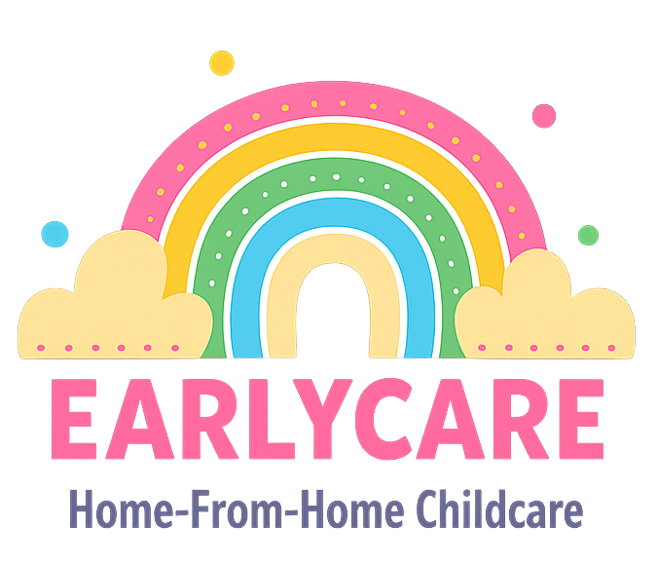

Earlycare

ADMINISTERING MEDICATION POLICY

Approval and Review

Manager | Mrs Hannah Bull
Signature | H.BULL
Policy Review Period | 12 months
Date of Policy Review | July 2026

Version Control

Version | Date Approved | Changes | Reason for Alterations
Initial | Jan 2024 | New policy
 | Jan 2025 | None
 | July 2025 | None

As a childcare provider, we will ensure that we implement an effective procedure to meet the individual needs of each child when administering medicines.

Procedure for administering medication

- We will obtain prior written permission from parents for each and every medicine to be administered before any medication is given. Parents will be required to provide instructions for when the medication is to be administered, how much is to be given and why. They will also need to let us know how many times/days the medication is to be administered for.
- We will keep written records of all medicines administered to children in our care, which both the staff member and a parent/carer must sign and date for each dose administered.
- We will store all medicines strictly in accordance with the product instructions, in their original container and out of reach of children. For safety reasons, medicines not supplied in their original containers or those without their instruction labels, will not be administered.
- We will only administer prescription medicine to a child if it is prescribed by a doctor, dentist, nurse or pharmacist. Such medication must clearly show the child's name and date of birth, along with instructions for administering the medicine.
- Non-prescription medicines, such as pain relief, will only be administered with parent/carer’s previous written consent and only when there is a health reason to do so. If we feel a child needs medication, for a reason specified on a general permission slip, we will contact the parent concerned and get permission verbally or via text or email on each occasion before it is administered. Please note that paracetamol should only be used as pain relief and with a medical practitioner's recommendation following vaccinations. It should not be used simply to reduce a temperature, as this can mask more serious conditions.
- We will never administer medicines containing aspirin to a child under the age of 16 unless they have been prescribed by a doctor.
- If we have a child with long-term medical needs then we will ensure that we have sufficient information about the child’s medical condition and will work in partnership with parents to assist the administration of any prescribed medication.
- If the administration requires technical/medical knowledge then staff members will attend training from a qualified health professional. The training should be specific to the child in question.
If your child has a medication that may be needed urgently, for example an asthma inhaler, please provide an additional supply for us to keep at the setting so there is reduced risk of them being without their medication.
It is vital that you inform us of any medication you may have given to your child in the 48 hours before they arrive into our care. Depending on the type of medication and the reason it has been given, you may be asked to keep your child at home for a day or two. Particularly for new medications and antibiotics, it may be necessary for you to monitor their condition and ensure they don't have a reaction.

