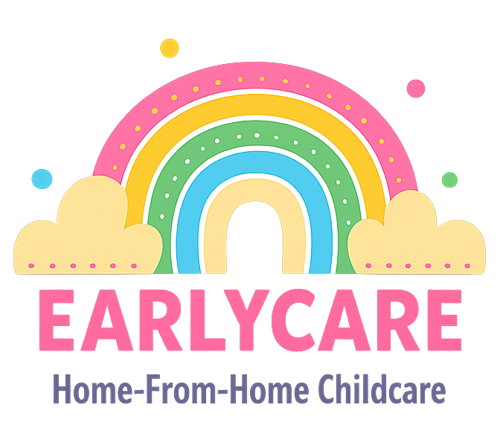

Earlycare

ADMISSIONS POLICY

Approval and Review

Manager | Mrs Hannah Bull
Signature | H.BULL
Policy Review Period | 12 months
Date of Policy Review | July 2026

Version Control

Version | Date Approved | Changes | Reason for Alterations
Initial | Jan 2024 | New policy
 | Jan 2025 | None
 | July 2025 | None

As an Ofsted registered setting, we are restricted to the number and ages of children that we can care for at any one time. These details are on our Ofsted Registration Certificate, which is displayed in the setting.
We are happy to take on any baby/child within our registered numbers, including those children who are entitled to funded places and will not discriminate against children or their families. If you decide that you would like your child to attend the setting, we will do our best to accommodate them within our staff to child ratios.
We already drop off and collect from Bishop Lonsdale School and therefore we are unable to collect children from any other school or preschool.
We are happy to take on children with special educational needs and disabilities, providing we feel we can provide them and the other children with the care they need.
All children are welcomed into the setting and we encourage the other children in our care to support us in this. We will request a settling-in period as part of our contract, so that if any party is unhappy with the arrangement it can be terminated easily.
When taking on new children, we must take into consideration the children already in our care who are happy and settled.
We currently offer 2 x three hour settling in sessions which are free. Subsequent settling in sessions can be arranged on an individual basis and these will be chargeable.
A Childcare contract will be signed upon completion of the settling in period. This will be subject to the child, staff and other children as well as the parents being happy to proceed with care on a regular basis.
If you have any concerns regarding our admissions policy, please do not hesitate to contact us.

