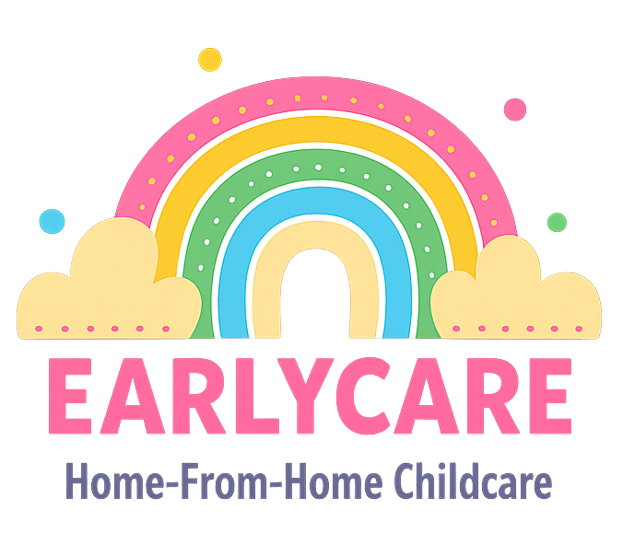

Earlycare

SUN PROTECTION POLICY

Approval and Review

Manager | Mrs Hannah Bull
Signature | H.BULL
Policy Review Period | 12 months
Date of Policy Review | July 2026

Version Control

Version | Date Approved | Changes | Reason for Alterations
Initial | Jan 2024 | New policy
 | Jan 2025 | None
 | July 2025 | None

We will do everything we can to ensure that your child is protected from the damaging effects of exposure
to the sun.
Throughout the summer and on sunny days, we will need you to provide your child with:
- high factor children's sun cream* that can be left in the setting (ideally SPF40-50 with a 4-5 star rating);
- a sun hat/cap (preferably a Legionnaires’ hat to protect the neck);
- a thin top/cardigan/T-shirt with long sleeves.
*Sun cream should be applied to your child's skin on any exposed areas (face, arms, neck, shoulders, legs, ears, etc.) before they arrive at the setting, to allow time for it to be absorbed into the skin and become effective.
In order to ensure the safety of your child on sunny days, we will also take the following precautions:
- We will reapply sun cream at intervals recommended on the NHS website and as necessary if children have been playing in the water or in a paddling pool. (Please sign the consent form giving permission for us to do this.)
- We will place the most popular resources and water-based activities in shaded areas of our outdoor space wherever possible.
- We will ensure that children seek shade or come indoors for adequate breaks, particularly between the hours of 11am and 3pm, when the sun is at its hottest.
- Children will have continual access to water and will be encouraged to stay hydrated during and after being outside in the sun.

